|  |  |  |
| --- | --- | --- |
| SCHOOL OF INFORMATION AND TECHNOLOGY | | |
| NAME: **OLIVAS, CARMIE SOPHIA N.** | DATE PERFORMED: **11 SEPT 2024** |  |
| Section: **IDC1** | DATE SUBMITTED: **11 SEPT 2024** |

# SYSADM1 – Managing Services in Linux

# Requirement:

* A virtual machine running Linux

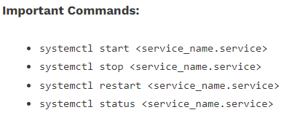

Complete this lab as follows:

Use the service –-status-all command to list all active and inactive services.

List down active and inactive services in the table below. Provide five (5) services for each column.

|  |  |
| --- | --- |
| **Active** | **Inactive** |
| alsa-utils | anarcon |
| cups | bluetooth |
| dbus | cryptdisks |
| openvpn | plymouth |
| sysstat | speech-=dispatcher |

SS:

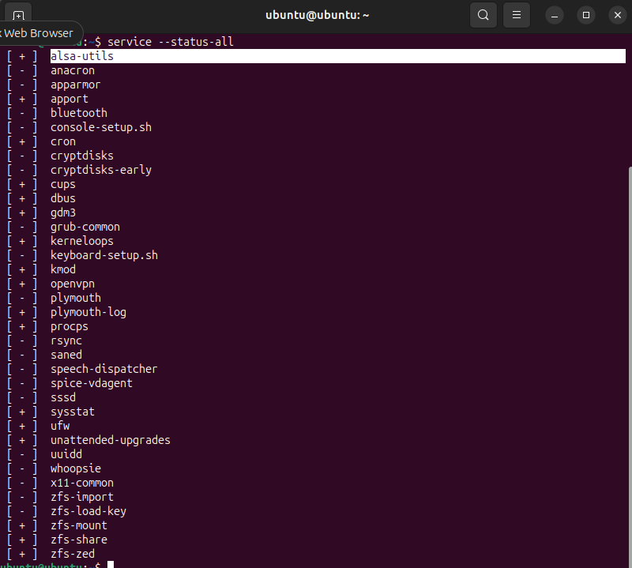

Start the Bluetooth service using the systemctl command.

Ex. sudo systemctl start httpd

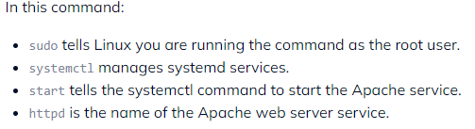



Check the status of the Bluetooth service. What is its status?

***The status is Active.***

SS:

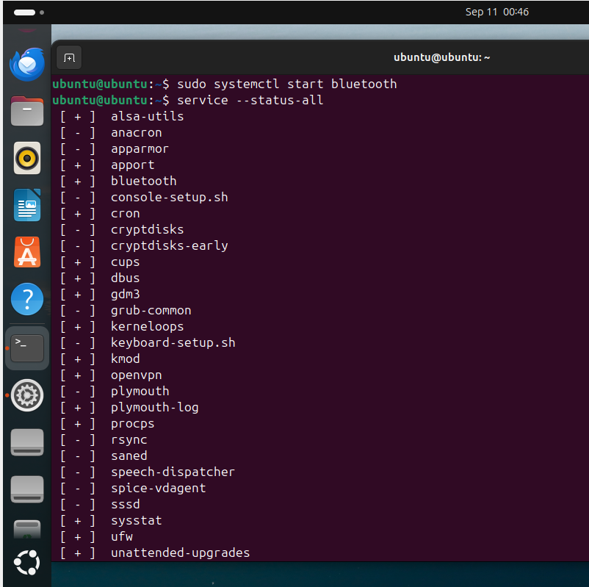

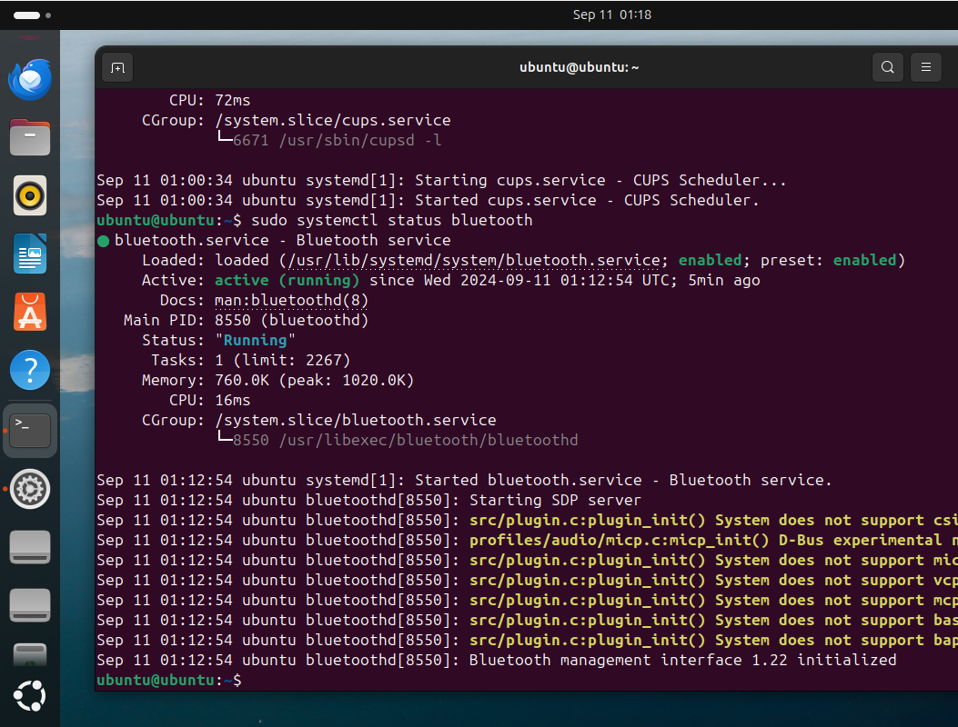

Check the status of the cups services. Since when was it running?

***It was already active and running when I issued the service –status-all command at the beginning.***

SS:

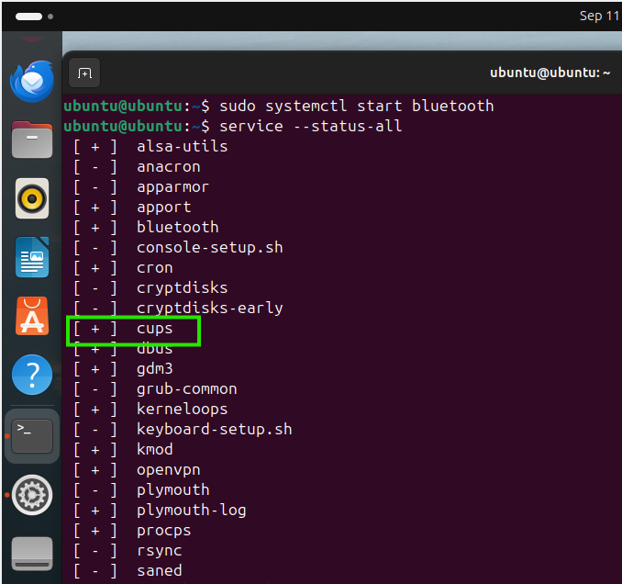

Stop cups services.



Verify if the service was stopped.

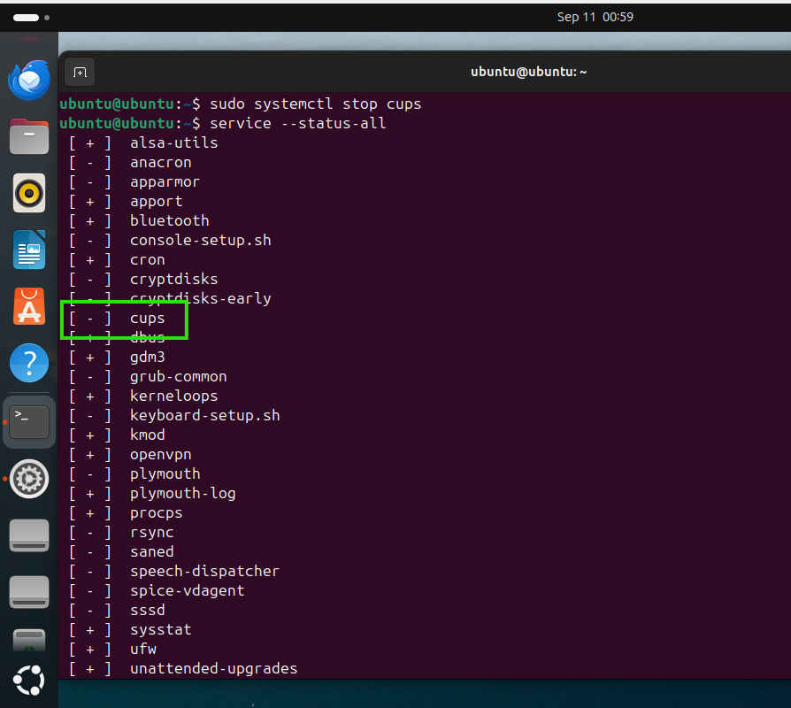

Restart the cups services



Verify if the service was restarted.

